What is ALM tool in testing?

**Application lifecycle management** (**ALM**) is the supervision of a software application from its initial planning through retirement. It also refers to how changes to an application are documented and tracked.

ALM is designed to support key stakeholders responsible for delivering applications as they progress through their lifecycle. It is a combination of a common platform, several key applications and a dashboard targeted at managing the core [lifecycle of applications](https://en.wikipedia.org/wiki/Application_lifecycle_management), from design through readiness for delivery to operations.[[3]](https://en.wikipedia.org/wiki/HP_Application_Lifecycle_Management#cite_note-informationweek.com-3) All of these core lifecycle activities are connected together from a workflow perspective with a common management console, layer of project tracking and planning and built on a common software foundation containing a consistent repository and open integration architecture with a supported SDK.[[4]](https://en.wikipedia.org/wiki/HP_Application_Lifecycle_Management#cite_note-4)

ALM is intended to provide [Information Technology](https://en.wikipedia.org/wiki/Information_Technology) departments with a centralized application management platform for managing and automating within and across application teams and throughout the complete process of developing an application, within a single workflow.[[1]](https://en.wikipedia.org/wiki/HP_Application_Lifecycle_Management#cite_note-Cio.com-1) HP offers a number of consulting services to support ALM.

What is an ALM tool?

A good **application lifecycle management** (**ALM**) package has software that is able to carefully manage and monitor all aspects of software development. **ALM** applications provide **tools** for managing and completing the phases of design, development, testing, deployment, and ongoing enhancements.

Components of HP ALM[[edit](https://en.wikipedia.org/w/index.php?title=HP_Application_Lifecycle_Management&action=edit&section=1" \o "Edit section: Components of HP ALM)]

**Project planning and tracking**[[edit](https://en.wikipedia.org/w/index.php?title=HP_Application_Lifecycle_Management&action=edit&section=2" \o "Edit section: Project planning and tracking)]

ALM provides project planning and tracking so application development solutions teams can define, track, measure, and report on project milestones and key performance indicators.[[3]](https://en.wikipedia.org/wiki/HP_Application_Lifecycle_Management#cite_note-informationweek.com-3)

**Application lifecycle intelligence**[[edit](https://en.wikipedia.org/w/index.php?title=HP_Application_Lifecycle_Management&action=edit&section=3" \o "Edit section: Application lifecycle intelligence)]

ALM delivers real-time traceability of requirements and defects. QA department can significantly benefit from this traceability to get on-time reports and have visibility into the system under development [[5]](https://en.wikipedia.org/wiki/HP_Application_Lifecycle_Management#cite_note-5)

**Lab management automation**[[edit](https://en.wikipedia.org/w/index.php?title=HP_Application_Lifecycle_Management&action=edit&section=4" \o "Edit section: Lab management automation)]

HP lab management capability allows testing teams to provision and deploy a test lab themselves in a hybrid delivery environment (bare-metal or virtual, in-house or in the cloud) through integration of HP ALM with HP Continuous Delivery Automation (CDA).[[6]](https://en.wikipedia.org/wiki/HP_Application_Lifecycle_Management#cite_note-6)

**Asset sharing and re-use**[[edit](https://en.wikipedia.org/w/index.php?title=HP_Application_Lifecycle_Management&action=edit&section=5" \o "Edit section: Asset sharing and re-use)]

ALM supports sharable asset libraries that can be reused across projects while maintaining traceability. Specific changes can be applied to shared assets for each project while maintaining library integrity, and projects can re-synch with the library as needed. Cross-project defect collaboration is also supported.[[7]](https://en.wikipedia.org/wiki/HP_Application_Lifecycle_Management#cite_note-7)

**Cross-project reporting**[[edit](https://en.wikipedia.org/w/index.php?title=HP_Application_Lifecycle_Management&action=edit&section=6" \o "Edit section: Cross-project reporting)]

ALM provides cross-project reporting and pre-configured business views for reports such as aggregated project status metrics, application quality metrics, requirements coverage, and defect trends for both an enterprise release and individual projects.[[8]](https://en.wikipedia.org/wiki/HP_Application_Lifecycle_Management#cite_note-resultspositive.com-8)

**HP Enterprise Collaboration**[[edit](https://en.wikipedia.org/w/index.php?title=HP_Application_Lifecycle_Management&action=edit&section=7" \o "Edit section: HP Enterprise Collaboration)]

HP Enterprise Collaboration uses social media for application development teams to communicate without leaving the HP ALM environment. Users can import relevant objects (defects, incidents, reports) for participants to review and comment on.[[9]](https://en.wikipedia.org/wiki/HP_Application_Lifecycle_Management#cite_note-9)

**HP Performance Center**[[edit](https://en.wikipedia.org/w/index.php?title=HP_Application_Lifecycle_Management&action=edit&section=8" \o "Edit section: HP Performance Center)]

Performance Center software is an enterprise-class performance testing platform and framework. The solution is used by IT departments to standardize, centralize and conduct performance testing, as well as [reuse](http://www.itcentralstation.com/product_reviews/hp-alm-review-33576-by-itdeveloper993)[[10]](https://en.wikipedia.org/wiki/HP_Application_Lifecycle_Management#cite_note-10) previous test cases. Performance Center finds software code flaws across the lifecycle of applications. Built on [HP LoadRunner](https://en.wikipedia.org/wiki/HP_LoadRunner) software, HP Performance Center supports developer testing and integrates with HP ALM.[[11]](https://en.wikipedia.org/wiki/HP_Application_Lifecycle_Management#cite_note-11)

**Quality assurance**[[edit](https://en.wikipedia.org/w/index.php?title=HP_Application_Lifecycle_Management&action=edit&section=9" \o "Edit section: Quality assurance)]

ALM includes quality assurance features for risk-based test planning and management, version control, baselining, quality release and cycle management, test scheduling and execution, integrated manual testing and defect management.[[8]](https://en.wikipedia.org/wiki/HP_Application_Lifecycle_Management#cite_note-resultspositive.com-8)

[HP Quality Center](https://en.wikipedia.org/wiki/HP_Quality_Center) is a quality management platform that can be used for a single project or across multiple IT projects to manage application quality across the entire application lifecycle. The solution provides requirements management, release and cycle management, test management, defect management and reporting from a single platform.[[12]](https://en.wikipedia.org/wiki/HP_Application_Lifecycle_Management#cite_note-12)

**Requirements definition and management**[[edit](https://en.wikipedia.org/w/index.php?title=HP_Application_Lifecycle_Management&action=edit&section=10" \o "Edit section: Requirements definition and management)]

ALM is used by IT departments to capture, manage and track requirements throughout the application development and testing cycle.[[13]](https://en.wikipedia.org/wiki/HP_Application_Lifecycle_Management#cite_note-13)

**Fortify security**[[edit](https://en.wikipedia.org/w/index.php?title=HP_Application_Lifecycle_Management&action=edit&section=11" \o "Edit section: Fortify security)]

Fortify security software, from [Fortify Software](https://en.wikipedia.org/wiki/Fortify_Software), provides application security software, including both dynamic web application security testing and static code analysis. HP Fortify security software integrates with ALM secure application delivery.[[14]](https://en.wikipedia.org/wiki/HP_Application_Lifecycle_Management#cite_note-14)

**Multi-environment support**[[edit](https://en.wikipedia.org/w/index.php?title=HP_Application_Lifecycle_Management&action=edit&section=12" \o "Edit section: Multi-environment support)]

ALM can be installed on-site or delivered through the cloud in a [Software as a Service](https://en.wikipedia.org/wiki/Software_as_a_Service) (SaaS) model.[[15]](https://en.wikipedia.org/wiki/HP_Application_Lifecycle_Management#cite_note-15) HP ALM is also available for mobile device support, including Apple iPhone and Android mobile devices.[[16]](https://en.wikipedia.org/wiki/HP_Application_Lifecycle_Management#cite_note-16)

# Introduction to HP ALM(Quality Center)

## What is HP ALM?

HP ALM (Application Life Cycle Management) is a web based tool that helps organizations to manage the application lifecycle right from project planning, requirements gathering, until Testing & deployment, which otherwise is a time-consuming task.

In its earlier avatar as Quality Center, the test management tool was developed by Mercury interactive.

It is now developed by HP as **A**pplication **L**ife Cycle **M**anagement Tool (or) ALM that supports various phases of the software development life cycle.

ALM also provides integration to all other HP products such as UFT and Load Runner.

## Why use HP ALM?

The various stakeholders involved in a typical project are –

* Developer
* Tester
* Business Analysts
* Project Managers
* Product Owners

These stakeholders perform diverse set of activities that need to be communicated to all concerned team members.

If we do not maintain centralized repository to record, maintain and track all the artifacts related to the product, the project will unquestionably FAIL.

We also need a mechanism to document and collaborate on all testing and development activities.

[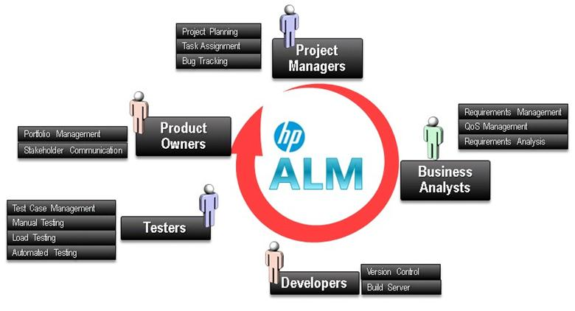](https://cdn.guru99.com/images/hpalm/071114_0703_Introductio1.jpg)

Enter HP ALM!

* It enables all the stakeholders to **interact and coordinate,** to achieve the project goals.
* It provides robust **tracking & reporting** and seamless integration of various project related tasks.
* It enables detailed **project analysis and effective management**.
* ALM can connect to our email systems and send emails about any changes(like Requirement change, Defect raising, etc..) to all desired team members.

## HP Quality Center Versions

It is important to understand the history of ALM.

* Quality Center was earlier known as Test Director which was developed by Mercury Interactive.
* In 2008, Version 8 was released, and the product was renamed as Quality Center.
* Later, HP acquired Mercury Interactive and rebranded all mercury products as HP.
* So Mercury Quality Center became HP Quality Center
* In 2011, Version 11 was released, and Quality center was rechristened as HP ALM.

[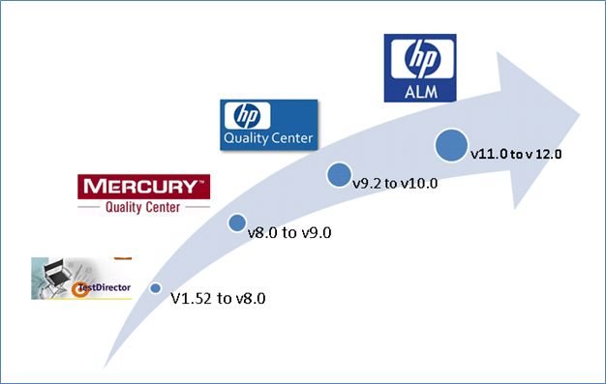](https://cdn.guru99.com/images/hpalm/071114_0703_Introductio2.png)

## 

## Architecture of QC

Now let us understand the technology part of HP-ALM. ALM is an enterprise application developed using[Java](https://www.guru99.com/java-tutorial.html)2 Enterprise Edition (J2EE) that can have MS[SQL](https://www.guru99.com/sql.html)Server or Oracle as its back end. ALM has 3 components – Client, Application Server and Database Server.

1. **HP ALM client:** when an end user/tester accesses the URL of ALM, the client components are downloaded on the client's system. ALM client components help the user to interact with the server using .NET and COM technologies over a secured connection (HTTPS).
2. **ALM server/Application server:** Application server usually runs on a Windows or[Linux](https://www.guru99.com/unix-linux-tutorial.html)platform which caters to the client requests. App server makes use of the Java Database Connectivity (JDBC) driver to communicate between the application server and database servers.
3. **Database servers**: The Database layer stores three schemas.

* **Site Administration schema:** It Stores information related to the domains, users, and site parameters.
* **Lab Project:** This schema stores lab information related to functional and [Performance Testing](https://www.guru99.com/performance-testing.html)on remote hosts, Performance Center server data.
* **Project schema:**Stores project information, such as work item/data created by the user under the project area. Each project has its own schema and they are are created on the same database server as the Site Administration schema.

[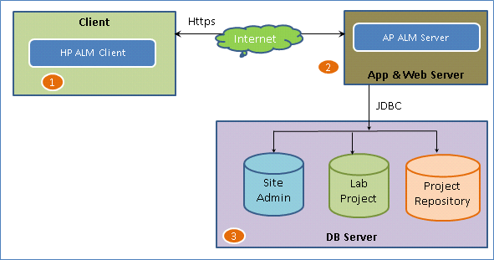](https://cdn.guru99.com/images/hpalm/071114_0703_Introductio3.png)

## HP ALM Editions:

HP ALM is a commercially licensed tool and HP distributes ALM in 4 different flavors

[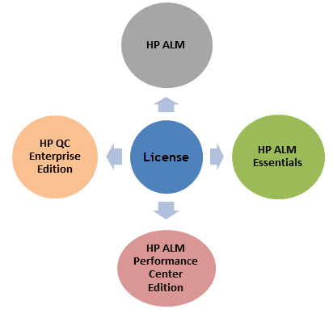](https://cdn.guru99.com/images/hpalm/071114_0703_Introductio4_v1.png)

## ALM Edition Feature Comparison

Each one of the license allows users to access certain ALM functionalities. Following Table lists the features that a particular license give you =

[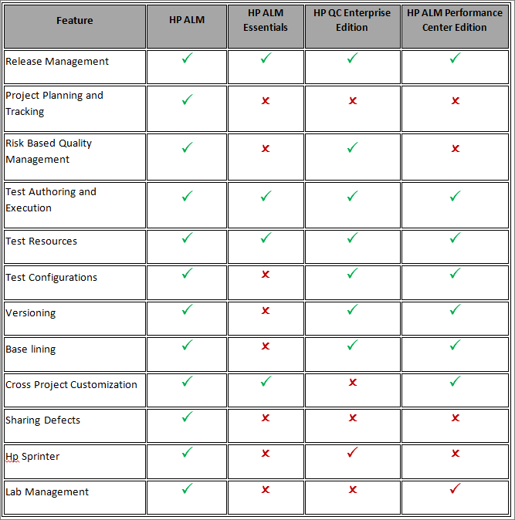](https://cdn.guru99.com/images/hpalm/071114_0703_Introductio6.png)

Let's study why would you purchase a particular version and whom is it suited for

* HP ALM Essentials – This is for corporates that need just the basic features for supporting their entire software life cycle. It has access to requirements management, test management and[Defect](https://www.guru99.com/the-unconventional-guide-to-defect-management.html)management.
* HP QC Enterprise Edition – This license holds good for corporates who would like to use ALM exclusively for testing purposes. It also provides integration with Unified Functional Tester (UFT).
* HP ALM Performance Center Edition – This license best suits for organizations who would like to use HP ALM to drive HP-Load runner scripts. It helps the users to maintain, manage, schedule, execute and monitor performance tests.

## ALM Workflow

To learn the ALM workflow, Let's first study a typical test process-

[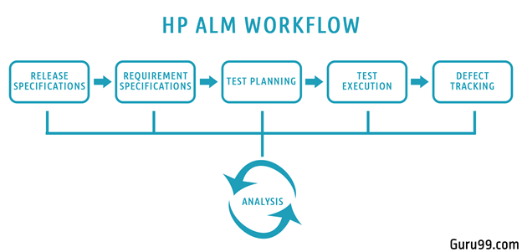](https://cdn.guru99.com/images/hpalm/071114_0703_Introductio5.png)

* We being with planning and drafting, Release details. Determine no of Cycles in each release & Scope of each release
* For a given Release and Cycle, we draft the Requirements Specifications.
* Based on the requirements, Test plans and test cases are created.
* Next stage is executing the created tests plan
* Next stage in this test processes is tracking and fixing the defects detected in the execution stage
* During all stages, analysis is done, and reports and graphs are generated for test metric generation.

HP ALM provides a module catering to each stage of the Testing Process. We will study them in detail in later tutorials.

# HP ALM Administration: Create Domain, Project & User

In order to work with ALM, you need to

* [Create Domain](https://www.guru99.com/hp-alm-create-domain-project-user.html#1)
* [Create Project](https://www.guru99.com/hp-alm-create-domain-project-user.html#2)
* [Create Users](https://www.guru99.com/hp-alm-create-domain-project-user.html#3)

In practice, these would be created by ALM Site Administrator as an end user WILL NOT have access to Site Admin page.

## How to Create a Domain

Step 1) Launch ALM and click 'Site administration' from the home page. User will be popped up to enter the credentials. Enter the Credentials that we have created during Installation.

[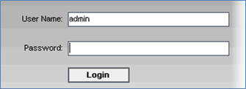](https://cdn.guru99.com/images/hpalm/071114_0715_CreateaDoma1.png)

Step 2) The Admin Dashboard is shown. Click on Create Domain

[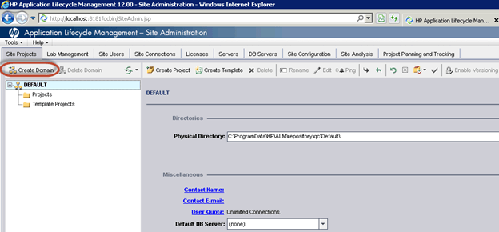](https://cdn.guru99.com/images/hpalm/071114_0715_CreateaDoma2.png)

Step 3) In the pop-up Enter Domain Name (in our case "Banking") and Click OK

[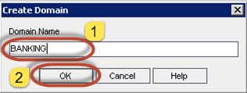](https://cdn.guru99.com/images/hpalm/071114_0715_CreateaDoma3.png)

Step 4) The domain would be created as shown below.

[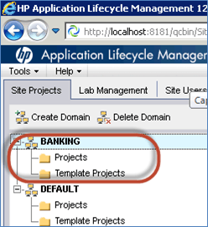](https://cdn.guru99.com/images/hpalm/071114_0715_CreateaDoma4.png)

## How to Create a Project

Step 1) Select the Domain under which projects are to be created. In this case it is 'Banking' Domain, and click 'Create Project' as shown below

[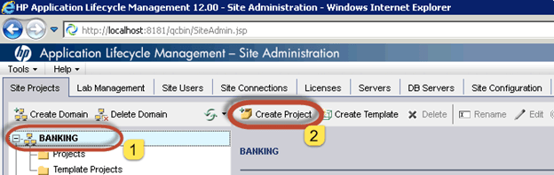](https://cdn.guru99.com/images/hpalm/071114_0715_CreateaDoma5.png)

Step 2) The 'Create Project' wizard opens. Select 'Create and Empty Project' from the list and click 'Next' button.

[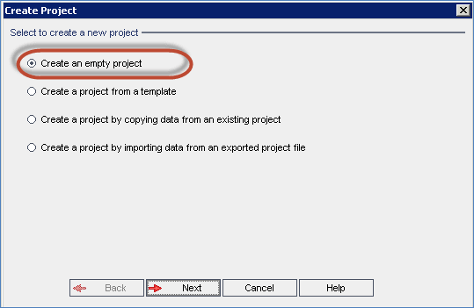](https://cdn.guru99.com/images/hpalm/071114_0715_CreateaDoma6.png)

Step 3) Enter the Name of the Project and click 'Next' as shown below.

[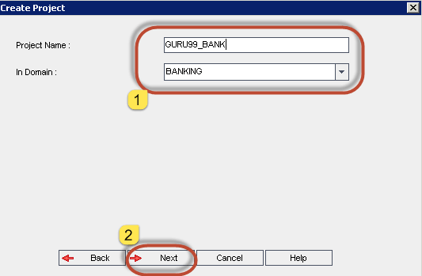](https://cdn.guru99.com/images/hpalm/071114_0715_CreateaDoma7.png)

Step 4) Select the appropriate Database type and enter the following. In this case, we have selected 'MS-SQL' as we had installed Hp-ALM with MS-SQL as backend. If you had installed ALM with Oracle as your database server, please select 'oracle'.

(1) Database server name

(2) Database Admin User Name

(3) Database Admin Password and click 'Next'.

[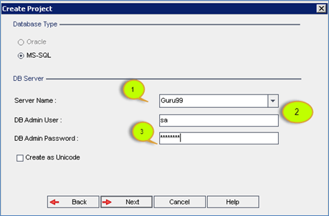](https://cdn.guru99.com/images/hpalm/071114_0715_CreateaDoma8.png)

Step 5) Select 'Admin' user and click 'Next'. No other users are displayed as we haven't created any users in ALM.

[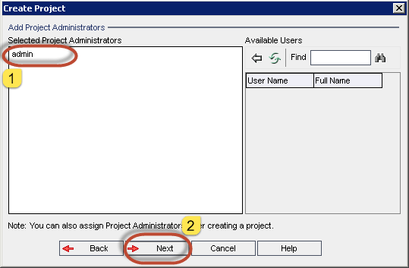](https://cdn.guru99.com/images/hpalm/071114_0715_CreateaDoma9.png)

Step 6) The summary dialog is displayed and Click on 'create' button. You will also notice that there are two check boxes in this window.

1. Activate Project – If unchecked, project would still be created but users will not be able to access this project area.
2. Enable Versioning – This will enable version controlling feature which restricts the users from editing the same work item (requirements, tests) at the same time to avoid overwriting the changes made by one user over other.

[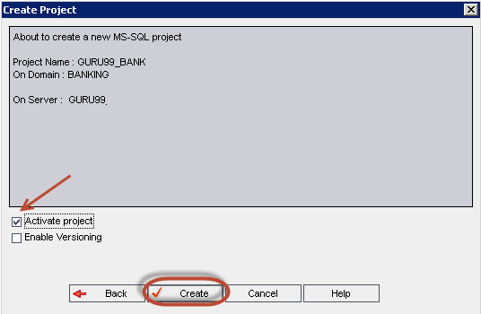](https://cdn.guru99.com/images/hpalm/071114_0715_CreateaDoma10.png)

Step 7) The project creation status would be displayed as shown below.

[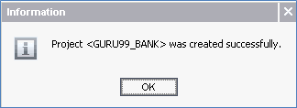](https://cdn.guru99.com/images/hpalm/071114_0715_CreateaDoma11.png)

Step 8) The project 'GURU99_BANK' has been created successfully under 'BANKING' domain as shown below.

[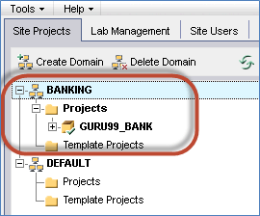](https://cdn.guru99.com/images/hpalm/071114_0715_CreateaDoma12.png)

## How to Create a User

Step 1) In order access HP ALM , a user profile needs to be created. In order to create users, site admin has to click on 'Site users' Tab.

[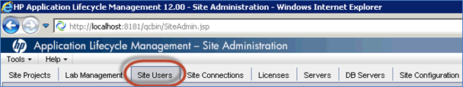](https://cdn.guru99.com/images/hpalm/071114_0715_CreateaDoma13.png)

Step 2) Click 'Add user' icon from 'Site users' tab as shown below.

[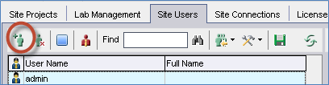](https://cdn.guru99.com/images/hpalm/071114_0715_CreateaDoma14.png)

Step 3) The 'Add user' dialog box opens. Enter all the necessary details and click 'OK'.

[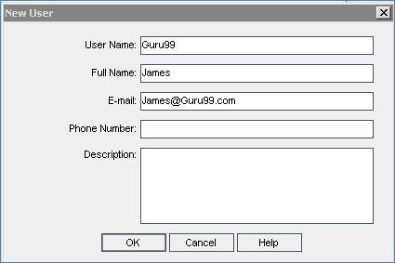](https://cdn.guru99.com/images/hpalm/071114_0715_CreateaDoma15.png)

Step 3) The Added user will be displayed in 'user list' as highlighted below along with the other existing users.

[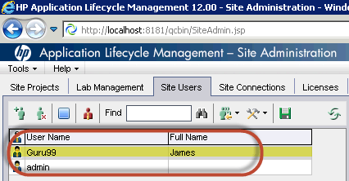](https://cdn.guru99.com/images/hpalm/071114_0715_CreateaDoma16.png)

Step 4) Now we will need to map the user to the project areas as the newly created user WILL NOT have access to any of the projects. It is enough to create a user only once to have access to multiple project areas.

In this case we have added the user 'Guru99' to 'GURU99_BANK' Project area which is under 'BANKING' domain.

[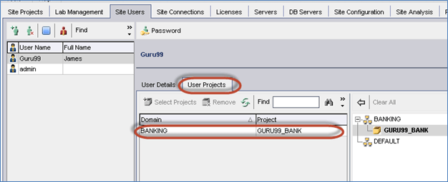](https://cdn.guru99.com/images/hpalm/071114_0715_CreateaDoma17.png)

# Management Tab: Create Releases & Cycles in HP ALM (Quality Center)

* Management Tab helps users to organize and track releases and cycles.
* A release has a definite start date and end date that corresponds to a group of changes that will be deployed to the end users in that time interval
* A cycle which falls within a release has a set of development and[Testing](https://www.guru99.com/software-testing.html)efforts in order to achieve a common goal.
* ALM users can track the progress of the project in real time by analyzing the releases tree to ensure if it matches the release goals.
* It also enables users to get a quick snapshot of the quality of that release which displays the outstanding[Defect](https://www.guru99.com/the-unconventional-guide-to-defect-management.html)and[Defect](https://www.guru99.com/the-unconventional-guide-to-defect-management.html)opening rate.

[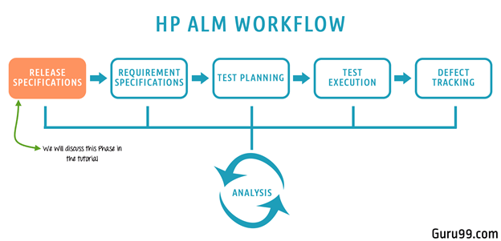](https://cdn.guru99.com/images/hpalm/071114_0728_ReleaseSpec1.png)

## Why do we need Management of Release and Cycles in ALM?

In reality, when a product development happens, there are various release for a particular product

* Each release is broken down into a number of cycles. Let's say we have got 2 releases with each having 2 cycles of development and testing for Guru99 banking application.
* Each Release has also a predefined scope and milestone associated with it.
* For each cycle there is a specific number of requirements.
* Each requirement has a number of test cases associated with it.
* Upon executing tests, the defects are logged and mapped to the corresponding tests after which we can trace requirements and defects.

[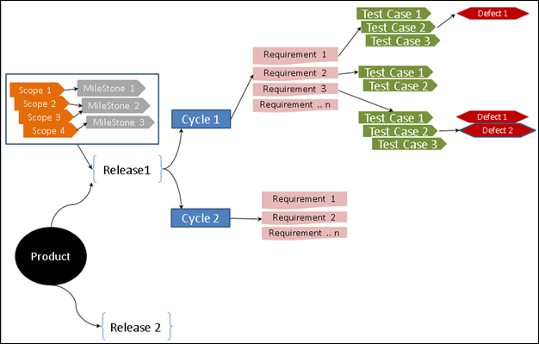](https://cdn.guru99.com/images/hpalm/071114_0728_ReleaseSpec2.png)

## The Management Tab

This module helps us to create and manage releases and cycles which is the first step before proceeding to create any work item such as requirements/tests/defects. It also helps us work with project planning and tracking. Following functionalities are vital in this tab.

* [Creating Releases](https://www.guru99.com/hp-alm-release-specifications.html#1)
* [Creating Cycles](https://www.guru99.com/hp-alm-release-specifications.html#2)
* [Creating Release Scope](https://www.guru99.com/hp-alm-release-specifications.html#3)
* [Create Milestone](https://www.guru99.com/hp-alm-release-specifications.html#4)

Note: before starting with exercise, refer this interactive tutorial to learn how to login in ALM

## How to Create a Release

Creating releases is the first step in ALM and all other work item such as requirements, test cases and defects are traced based on the releases/cycles.

As explained in workflow, we will have two releases this year for Guru99 banking application with the following timelines.

|  |  |  |
| --- | --- | --- |
| **Release Name** | **Start Date** | **End Date** |
| 2017 R1 | 01/01/2017 | 21/06/2017 |
| 2017 R2 | 01/07/2017 | 31/12/2017 |

Step 1) First step is to navigate to Management tab and click on "**Releases**" Tab. The landing page would appear as shown below:

[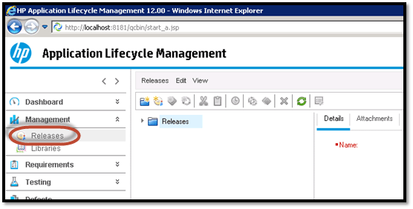](https://cdn.guru99.com/images/hpalm/071114_0728_ReleaseSpec3.png)

Step 2) Before creating a release, we can create a container/folder by clicking on a "**New Folder**" icon in releases module as shown below. Give the folder name 2017

[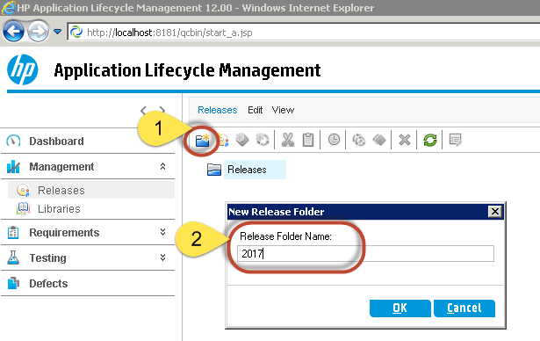](https://cdn.guru99.com/images/hpalm/071114_0728_ReleaseSpec4.png)

Step 3) Next step is to create new releases. To create a new release, click "**new release"** button and the New Release dialog opens. Enter the following mandatory details

1. Release Name
2. Start Date of the Release
3. End Date of the Release
4. Brief Description about the release (Optional)

[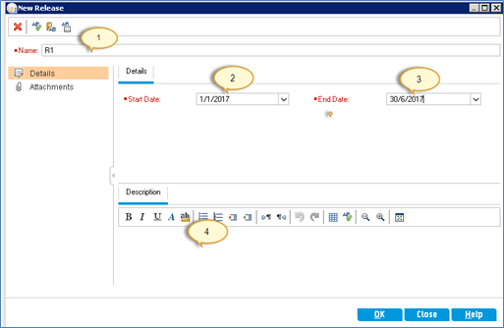](https://cdn.guru99.com/images/hpalm/071114_0728_ReleaseSpec5.png)

Step 4) After Entering the above details click "OK". The Release will be created as shown below.

[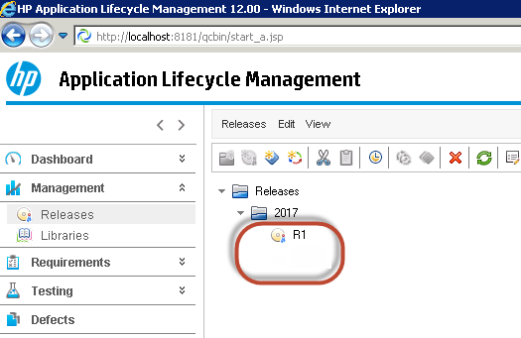](https://cdn.guru99.com/images/hpalm/071114_0728_ReleaseSpec6.png)

Likewise you can create other Release R2

Step 5) Upon Selecting a particular Release, one can see the tabs that are relevant to the Releases.

[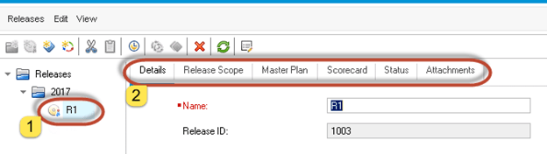](https://cdn.guru99.com/images/hpalm/071114_0728_ReleaseSpec7.png)

Step 6) Now let us understand the important tabs available under "Releases" Module. Select Details Tab to retrieve the information about the details of the release that was provided during the creation of the Release.

[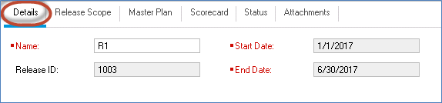](https://cdn.guru99.com/images/hpalm/071114_0728_ReleaseSpec8.png)

Step 7) Select **Release Scope** Tab that provides the details about the scope of that release. We haven't created scope for this release; hence the scope list is empty. Creation of milestones and scope will be dealt in detail in a separate module.

[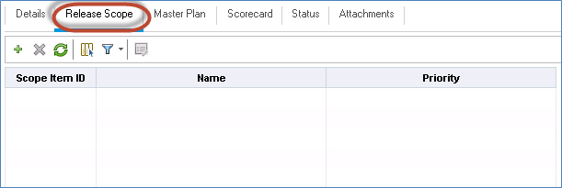](https://cdn.guru99.com/images/hpalm/071114_0728_ReleaseSpec9.png)

Step 8) Master Plan provides the pictorial representation of the timeline. If cycles are created, the master plan would include cycle timelines for that release as well.

[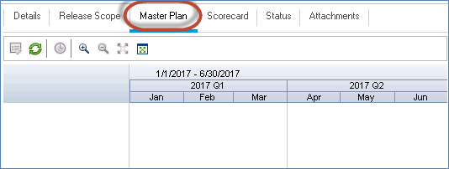](https://cdn.guru99.com/images/hpalm/071114_0728_ReleaseSpec10.png)

Step 9) Status Tab shows details about the release regarding the overall progress of that release.

* When the release is created afresh without any work item such as requirements/tests/defects added to it, the status would be displayed as shown below.

[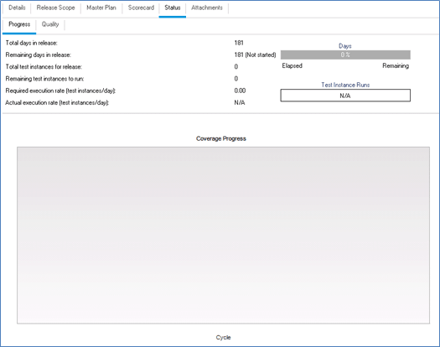](https://cdn.guru99.com/images/hpalm/071114_0728_ReleaseSpec11.png)

* The status would be displayed as shown below when user maps the work items such as requirements/tests/defects against the release.

[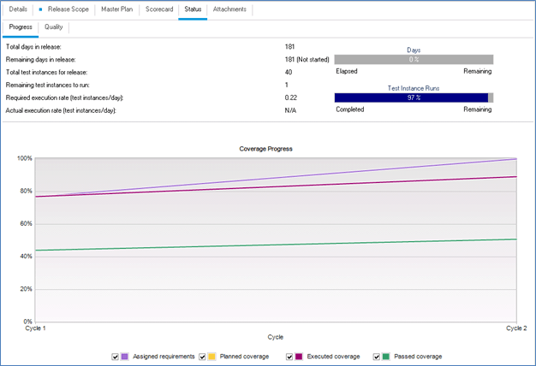](https://cdn.guru99.com/images/hpalm/071114_0728_ReleaseSpec12.png)

## How to create Cycle

In reality, each one of the releases is further broken down into cycles and let us understand how to create cycles in ALM. Let us say in our case there are two cycles in a release.

|  |  |  |  |
| --- | --- | --- | --- |
| **Release** | **Cycle Name** | **Cycle Start Date** | **Cycle End Date** |
| Release R1 | Cycle 1 | 01/01/2017 | 31/03/2017 |
| Cycle 2 | 01/04/2017 | 30/06/2017 |
| Release R2 | Cycle 1 | 01/07/2017 | 30/09/2017 |
| Cycle 2 | 01/10/2017 | 31/12/2017 |

Step 1)Select the Release under which you would like to create cycles and click on "**New Cycles**" button and the new cycles dialog box opens where the release timelines are prepopulated as this cycle is created under the selected release. User has to enter the following mandatory details in 'New Cycles' Window:

* Name of the Cycle
* Start Date of the Cycle
* End Date of the Cycle.
* Description (Optional)

[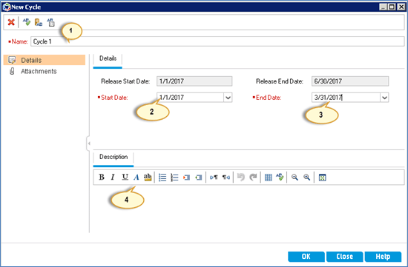](https://cdn.guru99.com/images/hpalm/071114_0728_ReleaseSpec13.png)

Step 2)Once all the cycle is created, user can access the same under created Release as shown below.

[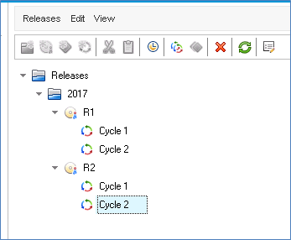](https://cdn.guru99.com/images/hpalm/071114_0728_ReleaseSpec14.png)

Step 3) Select a particular cycle to access details of that cycle.

[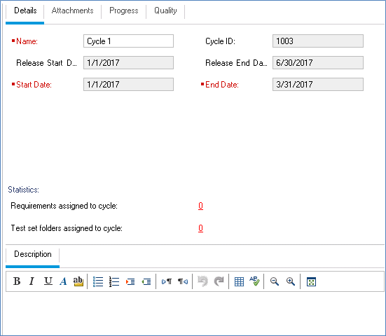](https://cdn.guru99.com/images/hpalm/071114_0728_ReleaseSpec15.png)

Step 4) Now let us understand all the other important tabs present under "Cycles". User can attach any attachment under 'attachments' Tab. 'The **Progress tab'** gives the status of that cycle under the selected Release.

* The Progress will be displayed as shown below when user created the cycle without any workitems(requirements/tests/defects) mapped against it.

[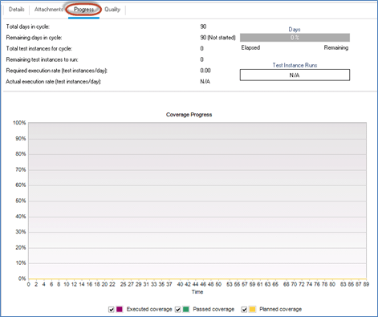](https://cdn.guru99.com/images/hpalm/071114_0728_ReleaseSpec16.png)

* The Progress will be displayed as shown below after user has mapped workitems(requirements/tests/defects) to the cycle.

[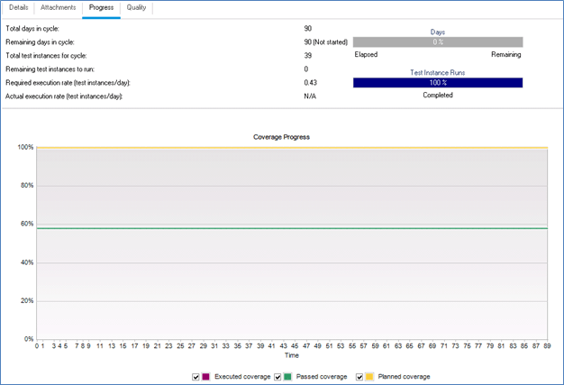](https://cdn.guru99.com/images/hpalm/071114_0728_ReleaseSpec17.png)

Step 5 ) The Quality Tab provides the information such as[Defect](https://www.guru99.com/the-unconventional-guide-to-defect-management.html)opening rate and number of outstanding defects which is the preliminary information about the quality of the current cycle.

* When the user has created the Cycle the 'Quality' Tab will be displayed as shown below as there are no workitems are mapped against it.

[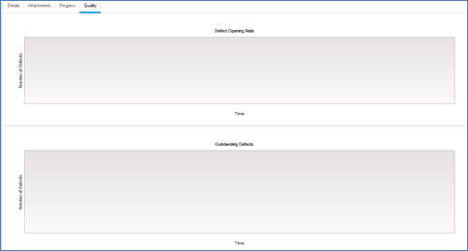](https://cdn.guru99.com/images/hpalm/071114_0728_ReleaseSpec18.png)

* The 'Quality' Tab will be displayed as shown below once the user has mapped work items against that release.

[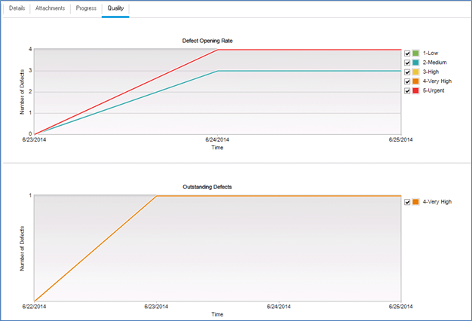](https://cdn.guru99.com/images/hpalm/071114_0728_ReleaseSpec19.png)

## How to Create Release Scope

Each Release has a scope and milestone associated with it that can be added under "**Release Scope**" Tab under Releases.

Step 1)Upon clicking on "+" icon in releases scope tab of releases module, **New Scope** dialog opens.

[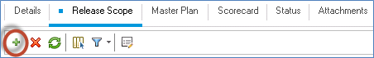](https://cdn.guru99.com/images/hpalm/071114_0728_ReleaseSpec20.png)

Enter the following details.

1. The name of the scope which is the only mandatory field
2. Priority of the Scope Item
3. Owner of the Scope.
4. Description about the Scope.

[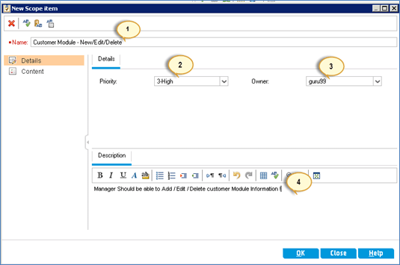](https://cdn.guru99.com/images/hpalm/071114_0728_ReleaseSpec21.png)

Step 2) Upon clicking on **"OK"**button, all the added scope is shown in the "**Release Scope**" tab as shown below.

[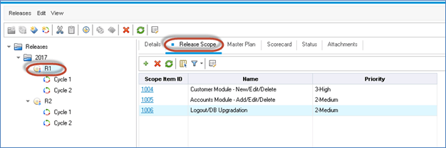](https://cdn.guru99.com/images/hpalm/071114_0728_ReleaseSpec22.png)

## How to Create MileStone

Step 1) New Milestone can be created only under a release using a "New Milestone" Icon as shown below.

[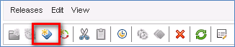](https://cdn.guru99.com/images/hpalm/071114_0728_ReleaseSpec23.png)

Step 2) While creating a milestone following fields are mandatory.

1. Name of the Milestone
2. Start Tracking Date
3. End Tracking Date.
4. Description

[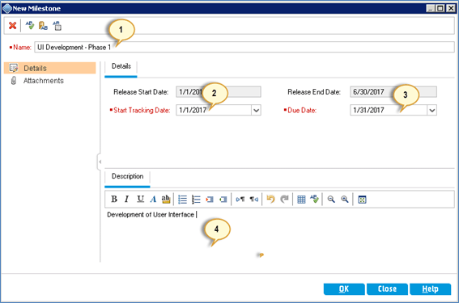](https://cdn.guru99.com/images/hpalm/071114_0728_ReleaseSpec24.png)

Step 3) The created Milestone is shown as below.

[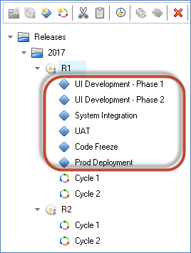](https://cdn.guru99.com/images/hpalm/071114_0728_ReleaseSpec25.png)

Step 4) Now user can map a milestone scope against the created project scope. To perform the same, select the milestone and navigate to Milestone Scope and select the corresponding scope and map it.

[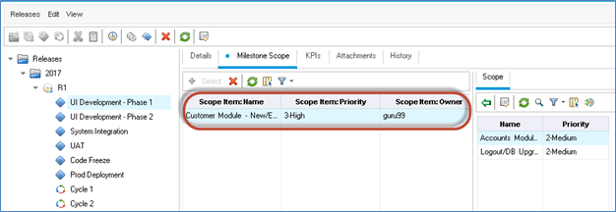](https://cdn.guru99.com/images/hpalm/071114_0728_ReleaseSpec26.png)

# How to integrate UFT(QTP) with ALM (Quality Center)

* ALM allows integration with other HP products such as HP UFT and Hp Load Runner.
* HP UFT is a functional automation tool that supports automation of both windows based and web based application. It also supports multiple technologies such as .NET, Java, Siebel, SAP etc.
* In this section we will understand how to drive UFT scripts from ALM. It consists of various configurations and steps.
* Prerequisite for this module is that both ALM and UFT must have been installed.

Following is the roadmap one needs to follow in oder to run UFT tests using ALM

[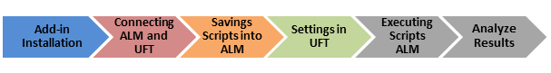](https://cdn.guru99.com/images/hpalm/071114_0934_Howtointegr1.png)